**Project no. 48721**

|  |  |  |
| --- | --- | --- |
| **RULEMAKING PROCEEDING TO AMEND 16 TAC §25.505, RELATING TO RESOURCE ADEQUACY IN THE ELECTRIC RELIABILITY COUNCIL OF TEXAS POWER REGION** | **§**  **§**  **§**  **§** | **Public utility commission**  **Of texas** |

**TEXAS COMPETITIVE POWER ADVOCATES (TCPA) REPLY COMMENTS ON THE PROPOSAL FOR PUBLICATION**

Texas Competitive Power Advocates (TCPA) is a trade association representing power generation companies, wholesale power marketers, and retail electric providers with investments in Texas and the Electric Reliability Council of Texas (ERCOT) wholesale electric market. TCPA members and their affiliates provide a wide range of important market functions and services in ERCOT, including the development, operation, and management of power generation assets, the scheduling and marketing of power, the provision of energy management services, and the sales of competitive electric service to consumers. TCPA members provide approximately sixty percent (60%) of the total net operable electric generating capacity in ERCOT, representing billions of dollars of investment in the state, and employing thousands of Texans.

TCPA appreciates the opportunity to provide the following replies to the initial comments in this proceeding:

* The Commission should reject the lukewarm suggestions to retain the Low System-Wide Offer Cap (LCAP), as well as the suggestion to place an artificial cap on Operating Reserve Demand Curve (ORDC) revenues.
  + Alternatively, if the Commission retains the LCAP, the Commission should adopt the recommendations by TCPA and others to (i) retain the ORDC and Reliability Deployment Price Adder (RDPA); (ii) reset the Value of Lost Load (VOLL) to LCAP in the event the LCAP is triggered, rather than suspend the ORDC or RDPA; and (iii) increase the LCAP to a higher level that is more commensurate with actual Real-Time Market (RTM) potential price outcomes (TCPA continues to recommend $4,500/MWh).
* The Commission should reject calls for modifying the peaker net margin (PNM) calculation, and the rule should retain a requirement for ERCOT to maintain that calculation regardless of whether the Commission eliminates or retains the LCAP mechanism.
* The Commission should adopt recommendations by TCPA and others to retain the rule language in subsection (f) requiring ERCOT to report various data to the market.

**I. Replies**

A. Replies to initial comments regarding LCAP mechanism and PNM

*1.* *In an energy-only market, competitive generators cannot “over-earn” or have “excessive” revenues, and the Commission should eliminate the LCAP mechanism and reject any suggestion to cap ORDC revenues.*

Calls to retain the LCAP mechanism were largely unenthusiastic, with the primary argument being that there should be some stop-gap measure to prevent generators from “over-earning” or earning “excessive revenues” and that the LCAP, while not particularly helpful, is the only one in existence.[1] Another commenter more forcefully suggested that the Commission set a fixed earnings cap on ORDC revenues for the same purpose, arguing incorrectly that the ORDC is “an external market intervention.”[2] For the reasons discussed below and in TCPA’s initial comments, the Commission should reject both of these suggestions.

The concept of “over-earning” or “excessive” revenues is misplaced in an energy-only competitive market construct in which the market price of energy dictates generator revenues. The market price of energy generally reflects the short-run marginal costs and risks of the marginal resource, absent scarcity conditions. During scarcity conditions, the scarcity pricing mechanism (i.e., the ORDC) results in an adder to the price of energy to reflect the value of diminishing operating reserves—as reserves deplete and the probability of a loss of load event increases in real-time, the ORDC operates to increase the energy price until it reaches the value that the Commission has determined (with input from a consultant and following months of deliberation[3]) that customers are willing to pay to avoid a loss of load event (i.e., the $9,000 VOLL). Further, such scarcity pricing provides important signals to the market that additional generation resources are needed both immediately and in the long term; and the market will respond to those signals by making additional resources available in real-time, as well as investing in new and existing resources, bringing mothballed resources back to operating status, and accelerating the timeline for new resource development and upgrades to existing resources. In other words, scarcity pricing is what incentivizes investors and existing resource owners to invest in new and existing resources.

In a competitive energy-only market, generators will earn the revenues that reflect the value of available supply on the grid. The idea that generators could “over-earn” or earn “excessive” revenues is a vestigial one rooted in the regulated utility construct, where rates are set by a regulatory body and paid by captive customers, and where there are no market forces to discipline the amount of revenues received. Indeed, the Public Utilities Regulatory Act (PURA)[4] §§ 11.002 and 31.001 specify that “public agencies regulate utility rates, operations, and service as a substitute for competition” because public utilities are “by definition monopolies in the areas they serve” such that “the normal forces of competition that regulate prices in a free enterprise society do not operate.” The legislature, in unbundling the ERCOT utilities to establish the competitive electricity market in Texas, found explicitly that “the production and sale of electricity is not a monopoly warranting regulation of rates, operations, and services,”[5] and that “the wholesale electric industry … is becoming a more competitive industry that does not lend itself to traditional electric utility regulatory rules, policies, and principles.”[6] Tellingly, the only mention of “excess revenue” in all of PURA is in relation to the abuse of market power and the Commission’s ability to order disgorgement of excess revenues deemed to have accrued due to a violation of PURA’s prohibition on market power abuse.[7] Taken together, it should be abundantly clear that it is by definition impossible for generators to earn “excess revenues” from competitive market prices.

The LCAP mechanism is thus not appropriate for a competitive energy-only market. Further, if the Commission were to place a cap on ORDC revenues or suspend the ORDC when revenues reach a certain point, the Commission would effectively be signaling to the market that the ORDC would be allowed to operate only when supply is abundant and would be preventing the ORDC from serving its very purpose—to reflect the value of operational reserves in times of scarcity and to signal the need for additional supply in real-time and in the longer term.

The argument that three times the cost of new entry (CONE) (i.e., the current LCAP trigger) would represent a catastrophic breakdown of the market is similarly flawed. As an illustration, for net revenues to reach the current LCAP trigger (i.e., $315,000/MW-year) under current market conditions, the annual average price of energy would have to be roughly $66/MWh:

* Under both the current and proposed rule, the PNM is calculated by subtracting the operating costs of a hypothetical peaker unit from the real-time price of energy, and those costs are based on the price of gas times an assumed heat rate of 10.
* Assuming the price of natural gas is $3 per MMBtu,[8] that would lead to a peaking operating marginal fuel cost of $30/MWh (i.e., $3/MMBtu x 10 heat rate = $30/MWh).
* For the PNM to exceed $315,000/MW-year, net revenues would need to equal approximately $35.96/MWh on average during the year:
  + $315,000/MW-year / 8760 hours per year = $35.96/MWh
* Adding the peaking operating cost of $30/MWh to the net revenues of $35.96/MWh equals an annual average wholesale energy price of $65.96/MWh.

The average price of energy exceeded $65.96/MWh both in 2005 and 2008[9]—while that price is higher than the average annual energy price over the past several years, it is hardly catastrophic and does not necessitate suspending or capping the revenues produced by the scarcity pricing mechanism (i.e., the ORDC) or lowering the system-wide offer cap (SWOC) to LCAP. If such a year occurred, the reasonable expectation would be for the market to respond by making additional resources available, and it is highly unlikely that such prices would persist.

TCPA continues to urge that the Commission eliminate the LCAP mechanism altogether and further urges that the Commission not place an arbitrary cap on ORDC revenues. The ORDC is a self-regulating mechanism, in the sense that it should incentivize resources to respond to scarcity pricing, both in real-time—by incentivizing resource owners to make all their resources available in real-time—and over the longer term—by incentivizing investment in new and existing resources in response to the scarcity pricing signals provided by the ORDC. As the available supply increases, the ORDC, by design, will diminish in effect, because the ORDC adders are based on the probability of a loss of load event.

*2. Customers should not be exposed to high real-time prices if their REPs are (as they should be) hedging their customers’ real-time price exposure.*

The contention that customers will be harmed by extended exposure to scarcity pricing in real-time is based on the flawed premise that customers are broadly exposed to real-time prices.[10] One of the primary benefits that retail electric providers (REPs) offer to their customers is protection from exposure to potential price volatility in real-time. Many customers are on fixed price contracts, meaning that their price cannot be changed in response to increases in real-time energy prices. But even customers on variable products generally should be protected from exposure to scarcity pricing in real-time, because their REPs, if acting responsibly, should have purchased a good portion of their wholesale power ahead of time (e.g., in the bilateral market) to mitigate the risk of exposure to high real-time prices. The impact to forward prices from a prolonged scarcity pricing period would also likely be mitigated (and thus so would forward contract prices), because forward prices reflect investors’ expectations of future market conditions, and the likely expectation would be that the market would respond to scarcity pricing – and thus the scarcity would not last over the longer term. It is therefore misleading to suggest that the *customer* will be exposed to high real-time prices if there is prolonged scarcity pricing unless the customer had knowingly contracted to accept that risk. While the *REP* may be exposed to high real-time prices in a prolonged scarcity pricing period, that is a risk that is wholly within the REP’s capabilities – as well as value proposition and fiduciary responsibility to the REP’s investors – to manage. And this is not a valid argument for suspending scarcity pricing in the event scarcity materializes, e.g., by placing a cap on ORDC revenues or resetting the SWOC to LCAP.

*3. The PNM calculation should not be modified as suggested in initial comments.*

As noted in TCPA’s initial comments, the Commission should require ERCOT to report the PNM for informational purposes, regardless of whether the Commission adopts the suggestion to eliminate the LCAP mechanism,[11] and TCPA generally supports the calculation of PNM set forth in the existing rule and the clean-ups to the rule language in the proposed rule. The PNM calculation is intended to transparently estimate the annual levelized net revenues (real time energy price minus peaking operating costs) that a hypothetical gas-fired peaking unit (i.e., typically, the marginal unit) could expect to earn.[12] It is not intended to perfectly represent the net revenues of an actual generator, but is a proxy based on objective, readily available data. For the reasons discussed below, the Commission should not modify that calculation as recommended in initial comments of some parties.

a. Suggestion to reduce multiplier for peaking operating cost from 10X to 8X

The current PNM calculation assumes that the hypothetical marginal resource has a heat rate of 10 MMBtu/MWh. A couple of commenters suggested that the 10 heat rate is an outdated measure, because new simple cycle units allegedly are more efficient and have an 8 heat rate.[13] The logic behind this suggestion is flawed for a number of reasons, not the least of which is that the mere existence of a more efficient combustion turbine does not alone make that unit the new standard reference. As with many machines such as vehicles, air conditioners, and home appliances, additional efficiency comes at a higher capital cost – but whether the additional efficiency is worthwhile to the purchaser depends on multiple factors. Therefore, it is irrational to assume that all purchasers choose the most efficient commercially available option.

In addition, while some newer gas units might be more efficient than a 10 heat rate, the price data for the past several years supports the use of a 10 heat rate for purposes of calculating the costs of the hypothetical marginal unit. As shown in the most recent report to the ERCOT Board by the Independent Market Monitor (IMM),[14] the average implied real-time market heat rate for the past five years has been almost exactly 10:[15]

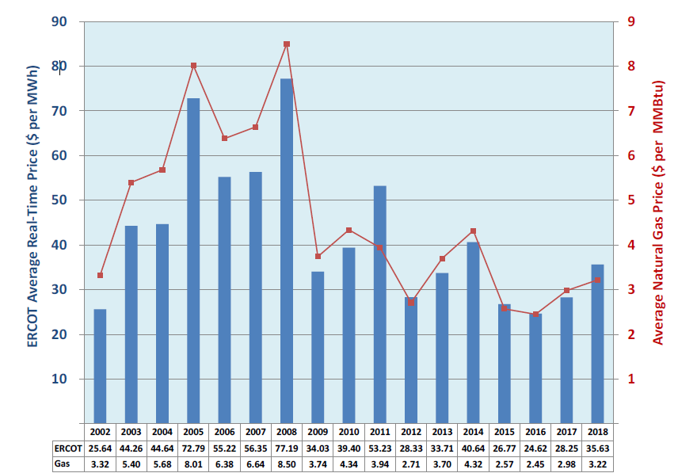



Therefore, the 10 heat rate in the current rule should be retained, because it more accurately reflects the heat rate of the marginal resource in the current ERCOT market. Even if more efficient simple cycle units are commercially available in the market, that efficiency has not been reflected in the real-time energy price so there is no empirical basis for changing the calculation of PNM.

b. Suggestion that PNM is under-stated because it is based on real-time prices rather than ancillary services, the Day-Ahead Market (DAM), or bilateral market, and assertion that PNM excludes ORDC and RDPA adders

Similarly, there is no rational or practical basis for modifying the PNM calculation as suggested by some commenters to somehow capture revenues from sources like ancillary services, the DAM, or bilateral markets, and the suggestion that PNM excludes ORDC and RDPA adders is misinformed, because those adders are already included by virtue of ERCOT’s use of the settlement point price to calculate PNM.

Ancillary services are not an additional source of revenue that should be *added* to the PNM, because they are *mutually exclusive* of energy—the same megawatts of generating capacity cannot be paid both for energy in the RTM and for ancillary services. If selected for ancillary services, a generator must reserve that capacity to be able to provide those services if called upon and cannot offer energy from that capacity. In addition, not every unit is capable of, or appropriate for, provision of ancillary services, and thus ancillary service revenues would not be a good substitute for real-time energy prices in approximating the net revenues for the hypothetical marginal resource. Additionally, as a practical matter, the value of capacity offered for energy or for ancillary services is inherently tied and should generally converge, because a rational generator should not offer its capacity for ancillary services if it believes it can get greater value from offering that capacity up for energy production and vice versa.

Likewise, the DAM is a purely voluntary financial market that is used to hedge exposure to real-time prices, and DAM outcomes generally converge with RTM outcomes, as is reflected in the graph below from the IMM’s latest presentation to the ERCOT Board:[16]

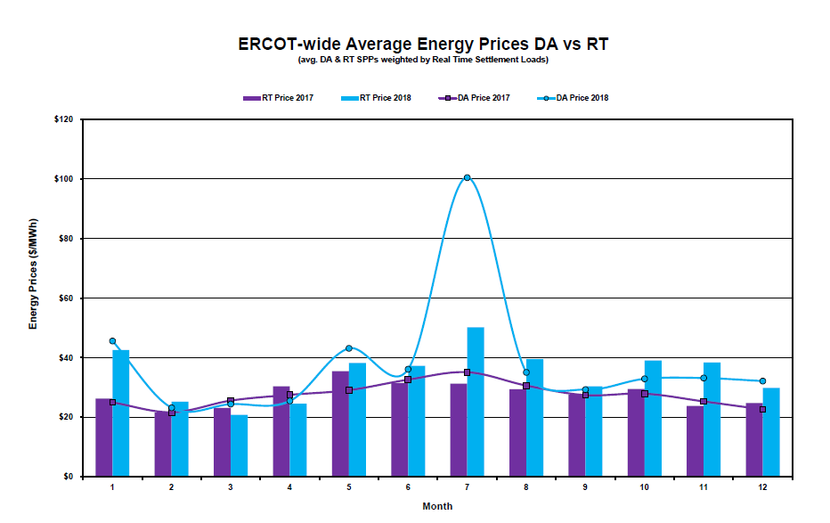

For the most part, the RTM price settles very close to the DAM price, which is the expected outcome in a well-functioning market because generators are financially held to their DAM offers – and as a result, rational generators should not be willing to sell in the DAM for much less than what they expect in the RTM (and loads should not be willing to pay much more in the DAM than they expect in the RTM as well).[17] Further, when there is divergence between the two, it varies as to whether prices settle higher in the RTM or the DAM. While the concerns expressed in initial comments are likely driven by the July 2018 DAM versus RTM results indicated in the chart above, that was clearly an outlier and should not be taken as indicative of the long-term convergence trend or a need to modify the PNM formula to swap out DAM for RTM prices (and certainly not add DAM to RTM prices). In addition, because the DAM is voluntary, many generators do not participate in it.

Similarly, the bilateral market is mutually exclusive of the RTM. Further, there is little-to-no visibility into the competitively-sensitive prices of bilateral contracts; and even if there was, the bilateral market would not be a useful metric for evaluating the net revenues of a hypothetical peaking unit because bilateral contract prices vary from generator to generator.

On the whole, real-time energy prices (which, contrary to certain comments, already do reflect adders from the ORDC and RDPA) are the best proxy for measuring the net revenues of a hypothetical peaker unit (i.e., the marginal resource). The real-time energy price is a reasonable, readily available and objective proxy to measure hypothetical net revenues, and more importantly, the real-time energy price is generally the price that drives the prices in other relevant markets and the overall revenue received by a generator.

*4. Alternatively, if the Commission retains the LCAP mechanism, the Commission (i) should adopt the recommendation to reset the VOLL to LCAP in the event the LCAP is triggered, rather than suspend the ORDC or RDPA; (ii) should increase the LCAP value to $4,500; and (iii) should limit the LCAP to offers (not the settlement price).*

In the event the Commission decides to retain the LCAP, TCPA agrees with the commenters that suggested the VOLL be reset to the LCAP if it is triggered, rather than suspend the ORDC and RDPA.[18] As indicated by those commenters, in the event of scarcity, the ORDC helps to ensure that the price reflects the value of avoiding a loss of load event and provides an important incentive to increase the availability of operating reserves during a scarcity event. The Commission should not suspend the ORDC altogether during the very circumstance (i.e., operational scarcity) that the ORDC was designed to address. Further, as discussed by TCPA in initial comments, the RDPA should be preserved because it is not a scarcity mechanism at all, but is necessary to correct for the price dampening impact of out-of-market actions taken by ERCOT.

In addition, if the LCAP is retained, TCPA agrees with the commenter that suggested the Commission consider increasing the LCAP,[19] and TCPA continues to recommend that it be increased to $4,500/MWh as discussed in its initial comments.

Further, TCPA agrees with the concerns pointed out by ERCOT with the proposed rule language that would cap the price – rather than just offers – at the LCAP.[20] As noted by ERCOT, such a rule change would “require ERCOT to undertake several changes to its market system at some public expense,”[21] because the current methodology for pricing congestion (which is a component of the locational marginal price) can result in prices that exceed the SWOC (whether the high system-wide offer cap (HCAP) or the LCAP) and because the formula for the power balance penalty curve can also result in prices that exceed the SWOC. TCPA continues to urge that, if the Commission retains the LCAP, the Commission limit only energy offers (rather than prices) to the LCAP.

The Commission also might consider moving to a longer resource adequacy cycle (such as 5 or 10 years) if the Commission opts to retain the LCAP mechanism. In an energy-only market, scarcity pricing and generator revenues are typically concentrated within one or two years out of a ten-year period, rather than evenly spread over each year.[22] Therefore, if the Commission retains the LCAP mechanism, it should consider evaluating net revenues over a longer timeframe—such as 5 or 10 years—and only triggering the LCAP if the rolling average annual revenues over that longer timeframe exceed the trigger.

B. Replies to initial comments regarding ERCOT reporting

TCPA agrees with the commenters that recommended retaining the ERCOT reporting requirements in subsection (f) of the current rule, with updates to streamline and remove outdated language related to the zonal market.[23] However, while TCPA supports cleaning up the rule language, it is important to retain the basic detail pertaining to the nodal market reporting requirements, to remove any ambiguity about what ERCOT must report.[24] In addition, one commenter suggested that, if the Commission decides to eliminate the rule requirements, it could closely monitor ERCOT Protocol changes that attempt to eliminate or reduce the existing reporting requirements[25]; while that is theoretically an option, it would create unnecessary work for the Commission, since the existing rule language already spells out what ERCOT must report and thus avoids the need for such monitoring. As explained in TCPA’s initial comments, the data reported by ERCOT under existing subsection (f) is valuable information to the market, and thus the Commission should retain that rule language, with the clean-ups proposed in TCPA’s initial comments.

C. Replies to initial comments regarding definition of load entity

One commenter suggested that the definition of “load entity” should be modified to refer to the definitions in the ERCOT Protocols.[26] However, the term “load entity” does not appear anywhere else in the rule language; and upon further inspection, neither do the terms “generation entity” or “resource entity.” In the interest of streamlining and cleaning up the existing rule language, the Commission should consider deleting those defined terms from the rule. The only definition that should be retained is the definition of “event trigger,” and, then, only if the Commission retains the reporting requirements in existing subsection (f), as recommended by TCPA and others.

**II. Conclusion**

TCPA appreciates the Commission’s consideration of its comments and continues to request that the Commission:

* Eliminate the LCAP, or, alternatively, (i) increase the LCAP to $4,500/MWh, (ii) if the LCAP is triggered, reset the VOLL to the LCAP for purposes of administrative pricing mechanisms like the ORDC and RDPA, and (iii) refrain from stating that prices will never exceed the LCAP if it is triggered.
* Retain but streamline and update the reporting requirements in existing subsection (f) of the rule, and if the LCAP is eliminated, add a requirement to that subsection for ERCOT to report on the PNM each day.
* Make the other stylistic revisions suggested in TCPA’s initial comments.

Dated: February 25, 2019

Respectfully submitted,

__________________________________

Michele Gregg

Executive Director

Texas Competitive Power Advocates (TCPA)

(512) 653-7447

[michele@competitivepower.org](mailto:michele@competitivepower.org)

1. *E.g.*, The ERCOT Steel Mills’ Joint Comments at 4–6 (Feb. 11, 2019) (hereafter, Steel Mills Comments); REP Group Comments on Proposed Rulemaking at 2 (Feb. 11, 2019) (hereafter, REP Group Comments); Texas Industrial Energy Consumers’ Initial Comments at 2–3 (Feb. 11, 2019) (hereafter, TIEC Comments).
2. *See* Steel Mills Comments at 5.
3. *See Commission Proceeding to Ensure Resource Adequacy in Texas*, Project No. 40000, London Economic International LLC, *Estimating the Value of Lost Load* (Jun. 17, 2013) (providing ranges for the value of lost load in ERCOT by customer class, which included the $9,000 value the Commission later adopted). The Commission began evaluating the ORDC as a potential scarcity pricing mechanism in November 2012 and ordered ERCOT to implement it (with a $9,000 value of lost load) at the September 12, 2013 open meeting. *See* Project No. 40000, IPR-GDF SUEZ Energy North America, Inc., Supplemental Comments (Nov. 14, 2012) (filing William W. Hogan’s paper, “Electricity Scarcity Pricing through Operating Reserves: An ERCOT Window of Opportunity,” which proposed the concept that ultimately became the ORDC).
4. Public Utility Regulatory Act, Tex. Util. Code Ann. §§ 11.001-58.302 (West 2016 & Supp. 2017), §§ 59.001-66.016 (West 2007 & Supp. 2017) (PURA).
5. *See* PURA § 39.001.
6. *See* PURA § 31.001(c)
7. *See* PURA § 15.023 (specifically, subsection (g) defines “excess revenue” as “revenue in excess of revenue that would have occurred absent a violation”) and PURA § 39.157.
8. *See* Potomac Economics, Item 11: Independent Market Monitor (IMM) Report for ERCOT Board of Directors Meeting at Slide 4 (Feb. 12, 2019) (showing a natural gas price of $2.45 in 2016, $2.98 in 2017, and $3.22 in 2018), *available at*: [http://www.ercot.com/content/wcm/key_documents_lists/161457/11_Independent_Market_  
   Monitor__IMM__Report.pdf](http://www.ercot.com/content/wcm/key_documents_lists/161457/11_Independent_Market_Monitor__IMM__Report.pdf).
9. *Id.* at Slide 3.
10. REP Group Comments at 2 (Feb. 11, 2019); Steel Mills Comments at 6 (Feb. 11, 2019); Texas Electric Cooperatives Comments at 2 (Feb. 11, 2019).
11. In addition to TCPA, Invenergy also suggested that the Commission eliminate LCAP. Comments of Invenergy LLC (Feb. 11, 2019).
12. *See* 16 Tex. Admin. Code (TAC) § 25.505(g); *Rulemaking on Wholesale Electric Market Power and Resource Adequacy in the ERCOT Power Region*, Project No. 31972, Order Adopting Amendment to §25.502, New §25.504, and New §25.505 as Approved at the August 10, 2006 Open Meeting, at 73 (Aug. 24, 2006).
13. TIEC Comments at 2 (Feb. 11, 2019); Steel Mills Comments at 3 (Feb. 11, 2019).
14. Potomac Economics, Item 11: Independent Market Monitor (IMM) Report for ERCOT Board of Directors Meeting at Slide 3 (Feb. 12, 2019), *available at*: [http://www.ercot.com/content/wcm/key_documents_lists/  
    161457/11_Independent_Market_Monitor__IMM__Report.pdf](http://www.ercot.com/content/wcm/key_documents_lists/161457/11_Independent_Market_Monitor__IMM__Report.pdf).
15. The market heat rate can be calculated by dividing the ERCOT average real-time price by the price of natural gas. The heat rate for 2018 was 11.07, for 2017 was 9.48, for 2016 was 10.05, for 2015 was 10.42, and for 2014 was 9.41; the average heat rate across those five years is 10.08.
16. Potomac Economics, Item 11: Independent Market Monitor (IMM) Report for ERCOT Board of Directors Meeting at Slide 12 (Feb. 12, 2019), *available at*: <http://www.ercot.com/content/wcm/key_documents_lists/161457/11_Independent_Market_Monitor__IMM__Report.pdf>.
17. *See* Potomac Economics, 2017 State of the Market Report for the ERCOT Electricity Markets at vii (May 2018) (“In a well-functioning market, participants should eliminate sustained price differences on a risk-adjusted basis by making day-ahead purchases or sales to arbitrage the price differences. . . . Price convergence was very good in 2017; day-ahead and real-time prices both averaged $26 per MWh. The average absolute difference between day-ahead and real-time prices was $8.60 per MWh in 2017 – a slight increase from $7.44 per MWh and $8.08 per MWh in 2016 and 2015, respectively.”).
18. Initial Comments of Texas Electric Cooperatives, Inc. at 2 (Feb. 11, 2019) (hereafter, TEC Comments); South Texas Electric Cooperative, Inc.’s Initial Comments at 2–3 (Feb. 11, 2019) (hereafter, STEC Comments).
19. STEC Comments at 3 (Feb. 11, 2019).
20. Initial Comments of Electric Reliability Council of Texas, Inc. (Feb. 11, 2019).
21. *Id.* at 2.
22. *See, e.g.*, Tr. of Dr. Patton Testimony to ERCOT Board at pp. 73–74 (Jun. 14, 2016) (“What you tend to get is -- shortages will increase exponentially with load -- unusually high load or unusually low generation availability. So what you should expect is whatever the average is over 10 years you’re going to get most of it in about two years and a big chunk of it in one year; you know, the kind of year you had in 2011. So in the other eight years I’m going to stand up here and say ORDC didn’t add a lot of value to the energy price, but that’s what we expect.”).
23. Initial Comments of the Lower Colorado River Authority at 2–5 (Feb. 11, 2019) (hereafter, LCRA Comments); Steel Mills Comments at 2–3 (Feb. 11, 2019).
24. LCRA’s suggested revisions would strip out much of the detail in the existing subsection (f). While TCPA agrees with LCRA’s arguments as to why the reporting requirements should be retained, TCPA prefers the redline that it suggested in its initial comments, so that there is no question as to what ERCOT must report.
25. Steel Mills Comments at 2–3 (Feb. 11, 2019).
26. REP Group Comments at 3 (Feb. 11, 2019).