**Project no. 48551**

|  |  |  |
| --- | --- | --- |
| **REVIEW OF SUMMER 2018 ERCOT MARKET PERFORMANCE** | **§**  **§**  **§**  **§** | **Public utility commission**  **Of texas** |

**TEXAS COMPETITIVE POWER ADVOCATES (TCPA) COMMENTS ON THE QUESTIONS REGARDING THE COMMISSION’S REVIEW OF SUMMER 2018 ERCOT MARKET PERFORMANCE**

Texas Competitive Power Advocates (TCPA) is a trade association representing power generation companies, wholesale power marketers, and retail electric providers with investments in Texas and the Electric Reliability Council of Texas (ERCOT) wholesale electric market. TCPA members and their affiliates provide a wide range of important market functions and services in ERCOT, including the development, operation, and management of power generation assets, the scheduling and marketing of power, the provision of energy management services and the sales of competitive electric service to consumers. TCPA members provide more than fifty percent (50%) of the total net operable electric generating capacity in ERCOT, representing billions of dollars of investment in the state, and employing thousands of Texans. TCPA submitted comments regarding Question 1 in its filing on September 14, 2018 and appreciates the opportunity to provide information in response to Questions 2 through 8 posed by the Commission.

**II. Responses to Commission Questions**

**2. Did the Operating Reserves Demand Curve (ORDC) as currently constituted perform as expected through the summer peak demand period? Were any anomalies observed in the functioning of the ORDC that would indicate a defect in its current implementation?**

As explained in the response to Question 1 filed on September 14, TCPA believes that the ORDC should produce scarcity prices that reflect reliability risk in the ERCOT market. The materially lower planning reserve margins in the summer of 2018 represented the first real test of the ORDC. This allowed for meaningful observation of its performance and the opportunity to adjust it to better align pricing outcomes with the needs of the market. In short, the ORDC failed to produce scarcity prices that reflected the reliability risk in the ERCOT market during the summer of 2018. The design of the ORDC, however, including the establishment of the input parameters, is not the result of a long history of proven science. Rather, the ORDC is a novel methodology rooted in a theoretical framework intended to approximate the economic value of reliability risk through scarcity prices and the Commission should expect an iterative process to refine its performance.

Considering its current configuration and the inputs observed, the prices produced by the ORDC this summer understated reliability risk and revealed the need to adjust the ORDC through an LOLP shift to more accurately reflect this risk. The Brattle Group (Brattle) recently updated its study on reserve margins in ERCOT and found that the market equilibrium reserve margin is expected to be 10.25%. Brattle highlights the reliability risk and the loss of load expectations that accompanies reserve margins near the market equilibrium reserve margin.

*At a market equilibrium reserve margin of 10.25% ERCOT can expect a probability-weighted average of 0.5 loss-of-load events (LOLE) per year. Our simulations find that there is likely to be a loss-of-load event about every two years in the range of 1,527 MW of load being shed for 3.2 hours on average, for a total expected unserved energy of 4,647 MWh. Such events would be more frequent, longer, and deeper at lower reserve margins and less so at higher reserve margins.[1]*

The planning reserve margins in ERCOT are forecasted to be near this level for the next five years fluctuating between 8.9% and 12.3%.[2] According to Brattle, a range of planning reserve margins this low would yield annual loss of load events between 0.22 and 0.81 per year of duration between 0.61 and 2.61 hours.[3] This clearly highlights the higher level of reliability risk expected in the ERCOT market in the foreseeable future.

TCPA appreciates the comprehensive information provided by ERCOT to allow for a thorough evaluation of ORDC performance. There were numerous observations this summer that reflected increased reliability risk on the ERCOT system.

First, during many days in the summer of 2018, the amount of peak load exceeded the total installed capacity of thermal generation resources.[4] This indicates that at times the ERCOT grid depended solely on renewable resources to serve load. This does not necessarily raise reliability concerns as long as the wind is blowing and the sun is shining enough, but it does represent a fundamental shift in the risk profile of the ERCOT market. Assuming this potential ongoing dependence on renewables to meet summer peak load is permanent, the reliability risk in ERCOT will be much more volatile.

Second, in the summer of 2018 nearly all available resources were required to be online many times to meet demand. For example, during the extended heat in July, there were nine days where available offline capacity declined to less than 1,000 MW.[5] As comparison, no such events occurred in the summer 2017.

Third, the ERCOT grid experienced a historically low amount of generation resource outages. This is presumably the result of a number of factors, including the strong financial incentives to maximize availability during times of anticipated scarcity pricing. However, sufficient investment in generation resources to sustain this level of exceptional resource performance may not be repeatable without realizing sufficient scarcity pricing. If the ERCOT grid experienced a normal amount of generation resource outages this summer consistent with the amount forecasted in the Final Summer SARA, it is likely that a severe grid emergency would have resulted. Assuming full availability of Emergency Response Service (ERS), Load Resources providing Responsive Reserve, and TDSP Load Management Programs, the actual operating reserve margin at the time of peak summer demand was 6%.[6] At reserve levels that low, analysis by the Brattle Group indicates the probability of a loss of load event increases exponentially.[7]

The pricing results for the summer of 2018 did not reflect this increased reliability risk on the ERCOT grid. The average ORDC adder for the peak load day was $29.74/MWh.[8] The average ORDC adder for the peak load hour was $342.87/MWh.[9] The average price for the months of June, July, and August was $39.34/MWh.[10] The accrual of Peaker Net Margin (PNM) this summer was less than $30,000/MW-Year and only approximately 37% of what was observed in the summer of 2011.[11] In comparison, in order to reach the Cost of New Entry (CONE) for a new Combined Cycle Generation Resource, the average price for the months of June, July, and August would need to be $60/MWh assuming an average price for the rest of the year of $25/MWh.[12] These results support TCPA’s concern that reserve margins must decrease further and reliability risk must increase further in order for the ORDC, as currently configured, to produce compelling scarcity prices to support existing generation and new investment.

Given this disconnect between reliability risk and pricing outcomes, TCPA recommends that the Commission direct ERCOT to shift the Loss of Load Probability (LOLP) by up to one full standard deviation. This adjustment is conservative and simple for ERCOT to implement. Besides better aligning scarcity pricing with reliability risk, such an adjustment would also help correct other observed deficiencies with the ORDC such as the step change increase in price that occurs at the Minimum Contingency Level (MCL, also referred to as the value of “X”), inadequate historical reference, inability to differentiate risk between tight days and normal days, and diluted contribution of renewable output on reserve error. The step change increase in the ORDC curve at MCL has been discussed in various filings and is assumed to be a well-known deficiency. Regarding inadequate historical reference, the current LOLP calculation assumes that there will be no operational surprises outside the range of history which may not be the case when reserves are lower.

The design of the ORDC does not fully differentiate the risk between tight days and normal days. This is due to how the ORDC views available capacity or reserves. The ORDC counts reserves that can be available within the next 10 minutes and 30 minutes to prevent load shed. Hence days with drastically different total reserve levels but with similar 10 minute online and 30 minute offline reserves would have the same price signals irrespective of how much additional capacity is available offline with longer than 30 minute start times. In other words, the ORDC does not value additional risk during times that have no more capacity available beyond the 10 minute and 30 minute capacity. Finally, the calculation of the reserve error in the LOLP determination uses the entire history of the nodal market. Installed wind and solar capacity has increased tremendously in the past several years and hence the error introduced by the variability in those resources has increased as well. All of these design deficiencies point to an overly conservative implementation of the ORDC that supports a need to shift the LOLP in order to better align scarcity prices with reliability risk.

Shifting the LOLP represents a logical initial step to conservatively adjust the ORDC to reflect reliability risk. In their report that introduced the concept, Dr. William Hogan and Dr. Susan Pope stated the following:

*An argument for changing the LOLP arises from a perspective to be conservative in the reliability estimates or due to the increased risk of renewable volatility on reserves. The current LOLP is taken from data and is the correct theoretical framework. However, the analysis assumes that the system operator has an accurate forward-looking model of the system and that there will be no operational surprises outside of the range of history. A natural response to adopting a conservative bias, given the relative lack of foresight or experience in operating a system heavily dependent on intermittent resources would be to make a judgmental adjustment in the margin of safety by shifting the LOLP.[13]*

A shift of the LOLP also has the benefit of being a straightforward and simple change to ERCOT’s existing implementation of the ORDC. This avoids costly or lengthy system changes. Dr. Hogan and Dr. Pope explain how the LOLP shift should be implemented:

*Stated in terms of the analytical description of the ORDC, a conservative shift of the LOLP would be a fraction of the standard deviation of the cumulative density function (CDF) estimated for system reliability given a level of hour-ahead reserves (R).*



*ERCOT calculates the mean (μ) and standard deviation (ơ) of the historical CDF, which follows a normal distribution. The conservative measure would be to shift the mean of the CDF function by up to one standard deviation using a scaling value between 0 and 1 (0<s<1). This shift would flow directly into the estimated LOLP, as the LOLP is equal to 1-CDF.[14]*

TCPA recommends that the Commission direct ERCOT to shift the LOLP by up to one full standard deviation in accordance with this guidance.

As stated in the response to Question 1, TCPA also recommends that the Commission direct ERCOT to simplify the ORDC by calculating a single LOLP curve to be applied the entire year. The Independent Market Monitor (IMM) pointed out this issue in the 2017 State of the Market report.

*Selected as an easier to implement alternative to real-time co-optimization of energy and ancillary services, the ORDC places an economic value on the reserves being provided, with separate pricing for online and offline reserves. The ORDC curves for 2017 are shown in Figure 16 below. The curves are determined in advance for four-hour blocks that vary across seasons. This depiction shows the breadth of distribution of the ORDC values across the year. The methodology leads to some large discontinuities between the curves where for the same reserve level the adder value changes significantly between adjacent time blocks. The largest such change in 2017 occurred in the summer season between 9:59 p.m. and 10:00 p.m. where the value of the ORDC curve changed more than $800 per MWh for a 3,000MW reserve level.[15]*



Calculating a single year-wide LOLP using historical reserve and reserve error data is also a very simple change for ERCOT to implement.

**3. Did observed levels of capacity, operating reserves, and demand during the summer peak demand period validate or invalidate the estimates contained in the Capacity, Reserves, and Demand (CDR) Report published in December 2017? Please describe in detail any observed variances between the CDR and actual levels of capacity, reserves, and demand.**

TCPA observed that actual non-synchronous tie capacity exceeded the December 2017 CDR projection by 2.4 times.[16] The 917 MW peak period imports were by far the largest variance to the estimate in the CDR, which had been forecasted to be 389 MW. As non-synchronous ties are inherently non-ERCOT resources that are not subject to SCED dispatch and are potentially price-suppressive when importing, it is notable that non-synchronous ties were both a contributor (in this instance) to meeting peak load needs and a detractor from peak load price formation.

**4. Did observed levels of capacity, operating reserves, and demand during the summer peak demand period validate or invalidate the estimates contained in the final Seasonal Assessment of Resource Adequacy (SARA) published in April 2018? Please describe in detail any observed variances between the SARA and actual levels of capacity, reserves, and demand.**

TCPA’s observations in Question 3 regarding the CDR are also applicable to the April 2018 Seasonal Assessment of Resource Adequacy (SARA). The estimates for non-synchronous tie capacity published in the SARA were 2.4 times less than the actual amount observed during the summer peak demand period.[17]

**5. What role did wind generation resources (WGRs) or other intermittent resources play in price formation during periods of resource scarcity during the summer of 2018? If WGRs or other intermittent resources had an adverse impact on price formation, what policy directives or market rules are needed to mitigate this impact?**

Intermittency of renewable resources is adversely affecting price formation in the ERCOT market during peak load conditions. The average prices this summer, like other periods throughout the year, were suppressed by the production of zero marginal cost intermittent renewable resources that would not have been built absent federal subsidies. Besides suppressing prices, the intermittency of renewables is also increasing the volatility of reliability in ERCOT.

The amount of renewable resources currently installed in ERCOT is more than double what it was at the start of the nodal market (~10GW in 2010 Vs ~22GW in 2018). With that and the increase in the percentage of installed capacity of renewables considered in CDR, the amount of variability in reliability that could be expected at a given planning reserve margin has significantly increased. This increased variability will continue year over year with the increase in non-firm renewable resource additions unless the net capacity becomes firm. Planning reserve margin is based on average wind output across the top 20 peak load hours, but there will always be high load hours or days when the wind production is much lower than the average causing the operational reserve margin to be much lower than planning reserve margin. The average expected wind and utility scale solar capacity contributed 5,311 MW of the 77,218 MW of capacity that counted towards the 9.3% reserve margin predicted for 2018 summer.[18] Based on the minimum and maximum capacity factors for these resources in the historic 20 peak hours of each year, even if all other resources operated perfectly, *the operational reserve margin that could materialize from a 9.3% planning reserve margin could have been anywhere from 3.2% to 18.9% just from the variability of these resources.[19]* The chart below demonstrates the wide variation in output from renewable resources during peak load periods that drive the CDR planning capacity factor contributions. Actual renewable output during peak hours can vary from as little as 1/10th of the CDR-assumed capacity to as much as 3 times the CDR-assumed capacity.[20]

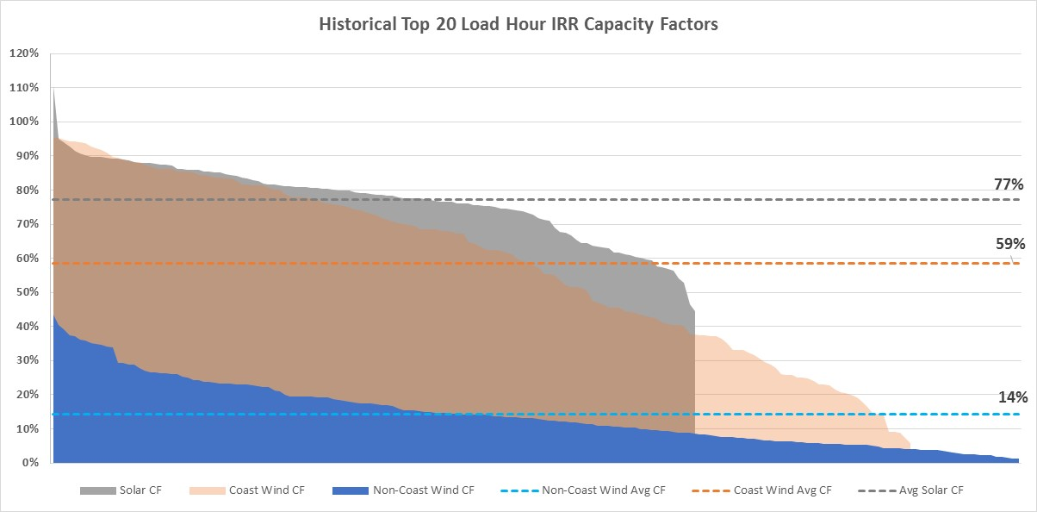

This is a problematic disconnect between reliability preferences and market signals for reliability. The Brattle Group (Brattle) recently updated its study on reserve margins in ERCOT and found that the market equilibrium reserve margin (MERM) was reduced by 0.5% from their prior 2014 study results just from additional renewables that would come online by 2022. The study also found that just adding half of the renewable capacity currently undergoing interconnection would further reduce the MERM by an additional 1.0%, resulting in an additional 0.25 expected load shed events per year, concluding that this indicates “a future of declining reliability with increasing renewable capacity” unless there is a corresponding change to the ORDC or fundamental shifts in the costs of natural gas or energy storage.*[21]* Assuming that market-based investments are based on average pricing signals, invested firm capacity would be enough to support the reliability events only when the intermittent renewable resource (IRR) production is similar to or more than the level considered in the average reserve margin levels. However, that level of investment might not be enough to ensure reliability under low IRR production scenarios when the operational reserve margin could be very low. In other words, IRR peak load capacity factors vary widely enough to result in asymmetric risk to ERCOT reliability. Hence, to be in line with the level of tolerance for reliability events, additional scarcity pricing changes are needed to improve predictability and therefore reliability by incentivizing new builds of and maintaining existing non-intermittent resources in order to support reliability. This will ensure that the whole range of operational reserve margin capacity will be higher for a given planning reserve margin level and hence reduce the potential for reliability events under low IRR production levels.

The impacts of IRRs on price formation happen not just in summer but throughout the year. As discussed by Dr. Hogan and Dr. Pope, the size and extent of the investments in the subsidized assets or programs in ERCOT is not consistent with what a risk-taking investor would willingly invest based on the ERCOT energy market revenues. This additional investment, which might not have been here without the subsidies, has had a major suppressing effect on prices not just in summer, but throughout the year. Market design should consider this negative externality on investment in firm electricity assets needed to sustain reliability.

The production from IRRs over the peak hours in summer rose from less than 1,000 MW in 2012 to more than 7,500 MW in 2018, which is more than 2,000 MW higher than the production in 2017.*[22]* The installed capacity of IRRs has roughly doubled from a little over 11 GW in 2012 to more than 22 GW in 2018. This trend is still continuing as there is already more than 15 GW of IRRs with signed interconnection agreements and more than 55GW of IRRs in different stages of study process.*[23]* The level of price suppression caused by these IRRs depends on many factors like the load level, the commitment pattern, marginal resource offer, steepness of the supply curve, gas prices, and forecast error of these IRRs. The two graphs*[24]* below show the impact of shifting of supply curve by this additional anticipated IRR capacity, adjusted for the respective current CDR capacity factors. These graphs are generic marginal cost-based examples produced by ERCOT and simply modified by TCPA to show a straightforward outward shift; as such, the impact under actual market scenarios would likely be greater than these visuals imply.

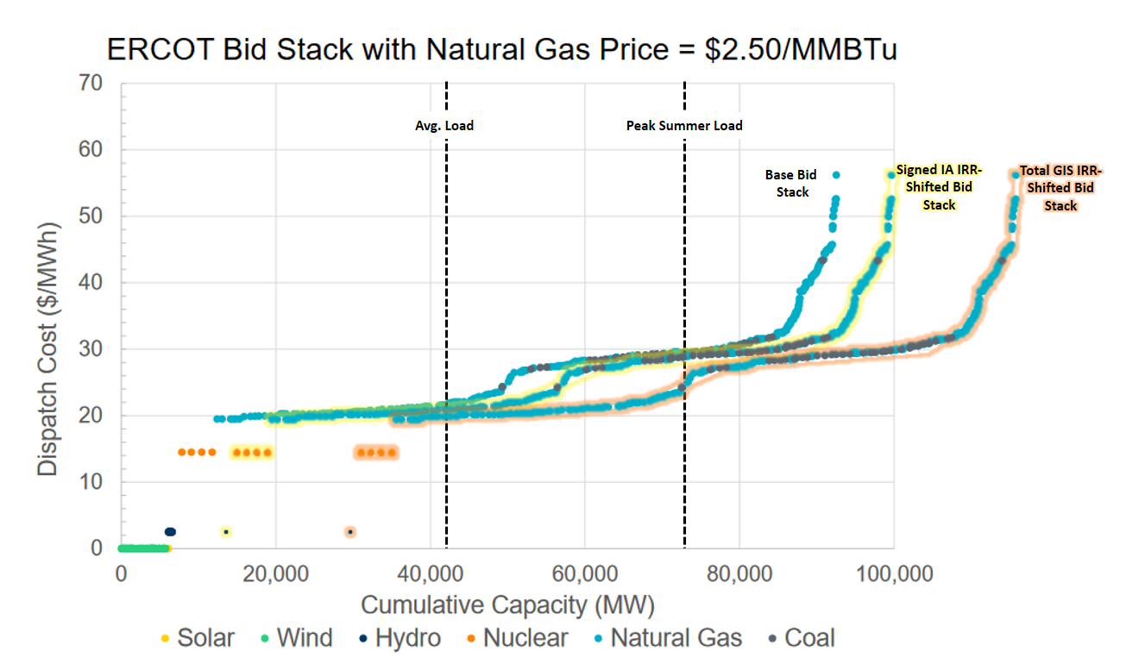

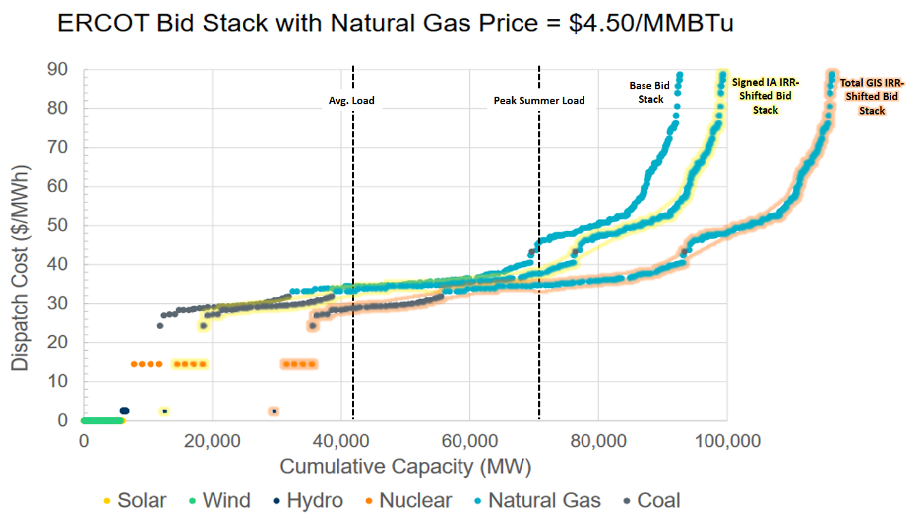

Market design could be tweaked in different ways to better incentivize reduced intermittency and investment in dispatchable electricity assets needed to sustain reliability. Changes could range from partially offsetting price suppression by ORDC modifications to creating new Ancillary Service products for services like ramp and inertia, or perhaps even incentives to hedge summer energy over a longer term. TCPA recommends at this time that the Commission direct ERCOT to shift the LOLP by up to one full standard deviation as an initial conservative step to not only address the concerns raised in TCPA’s response to Question 1 but also to partially offset the price suppressing effects of intermittent resources which might not have been here without the subsidies. TCPA also recommends that the Commission direct ERCOT and stakeholders to explore the additional market design changes needed to create incentives to reduce intermittency and improve reliability (but does not make any specific recommendation at this time).

**6.       What impact did ERCOT forecasts of wind generation and demand have on prices or price formation during the summer peak demand period? If ERCOT demand or wind forecasts had an adverse impact on prices or price formation during the summer peak demand period, how might this impact be mitigated?**

TCPA recognizes ERCOT's continual improvement in wind and load forecasting.  Forecasts inherently must have errors and the goal of forecasters is to minimize the magnitude of those errors. Large errors between the day-ahead market (DAM) and real-time market (RTM) can and do have a material impact on price formation – particularly if a single forecast model (such as ERCOT’s) is given outsized weight or relied upon exclusively by market participants.

Generally, if wind forecasts in the DAM are higher, generator owners may forgo starting generators assuming net demand (and prices) will be lower.   If the actual wind generation in the RTM is lower than forecasted, generation owners may no longer have the time necessary to start additional generation.   As a result, RTM prices in this scenario are generally higher than expected.  Conversely, when wind forecasts are lower in the DAM, generator owners may opt to commit generation assuming it will be needed for the RTM.   If the wind over performs the forecasts, operating reserves will be high in the RTM and prices will be low - at times lower than the actual cost of the generators who opted to come online expecting higher net-load.

While forecast error is unavoidable, it is the over-forecasting of wind that can have more direct reliability consequences since the RTM may be left short of online resources necessary to meet demand. Under-forecasting wind can also have longer-term reliability consequences if systemic, driving RTM prices lower relative to forward and DAM prices, and slowly but insidiously eroding forward price formation, in turn reducing the incentive to make investments in generation.  Market signals for resources to meet short-notice lack of supply, or unexpected demand are crucial to the success of the ERCOT market.    Importantly, such signals are also used to determine investment and technology choices for the future.  To improve these signals TCPA recommends the Commission implement the incremental changes to LOLP previously suggested identified by TCPA in its September 14, 2018 comments in this project.[25]   These changes will provide some market-based mitigation to the negative reliability effects created by normal wind forecast error.

For example, the effects of under-forecasting can be seen on July 23rd, which had DAM prices of $2000 compared to RTM prices of $100/MWh.  According to ERCOT, DAM conditions were expected to be very tight leading to commitment of almost all available generation.[26]  In the RTM, however, the wind over-performed the DAM forecast significantly (see figure below).  The under-forecast of wind is a contributing factor in the price difference since it directly leads to more reserves on the system.   It is likely that generators that were committed due to the $2000 DAM price ultimately would not have been committed if the DAM expectations matched the RTM outcomes.

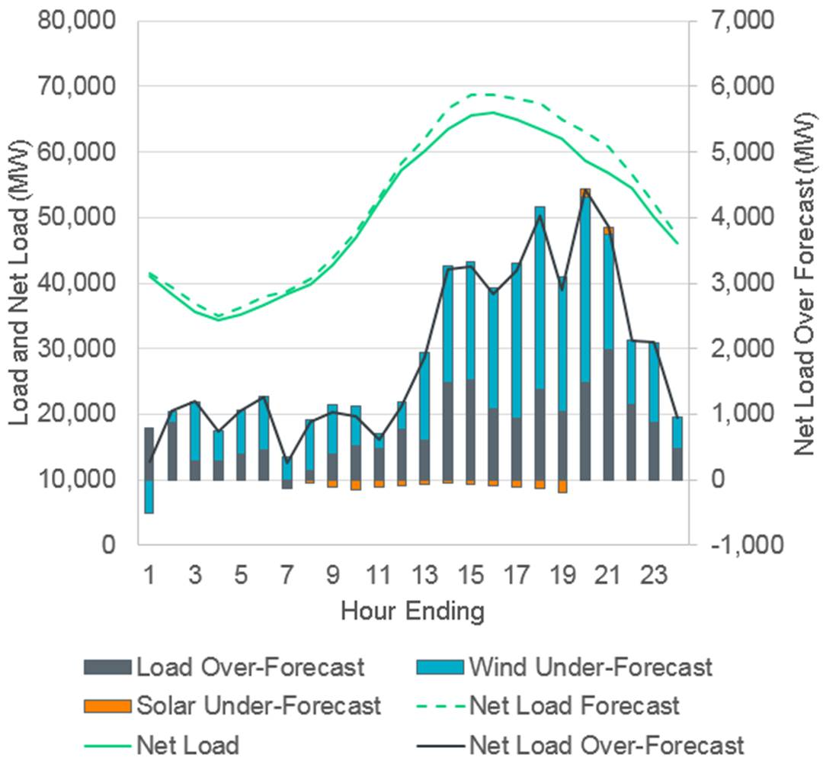

**7. What impact did demand response, including response to potential Four Coincident-Peak days, have on prices or price formation during the summer peak demand period?**

TCPA recognizes that many retail electric providers and their customers engage in demand response that is economically driven by wholesale energy prices (or expectations thereof). However, most of the impact of those activities are proprietary and not easily quantified. As such, TCPA responds only to the part of the question regarding the Four Coincident-Peak (“4CP”) impact on prices and price formation.

While ERCOT does not typically submit its official report identifying the 4CP days and intervals until the end of November each year,[27] and analysis of 4CP-driven load reductions is typically not reviewed until the following Spring at the earliest,[28] prior years’ 4CP response provides reference for likely 4CP impacts during the Summer of 2018. ERCOT’s Review of Summer 2018 (June-August) presentation, filed in this project on September 24, 2018, includes one slide that is particularly indicative and shows a clear growth trend in 4CP-driven load reductions from 2014 through 2017:[29]

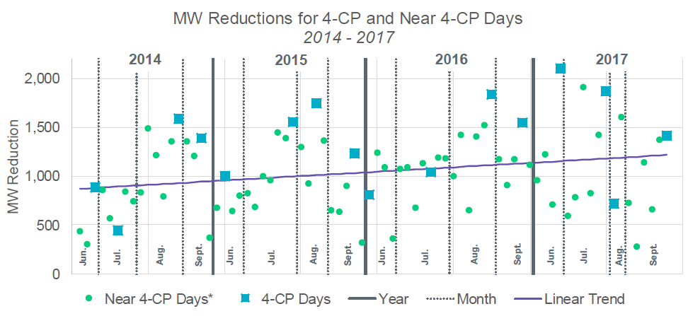

The chart is fairly clear that 4CP-driven demand response can range from ~250 MW to more than 2,000 MW, but averages around 1,000 MW and is growing. Notably, this analysis includes both actual 4CP days and *near*-4CP days. The latter is reasonably monitored because 4CP-responsive loads[30] often do not know with certainty which day will be the 4CP day (or which interval, even though it is almost always during the hour ending at 5pm, or HE1700), and there are therefore oftentimes “near misses” for 4CP that still result in 4CP-driven demand response. However, a closer inspection of ERCOT’s chart shows that the *actual* 4CP load reductions tend to be well above the trendline average – out of the 16 4CP days shown, only three are noticeably below the trendline and another three are basically on the trendline, but the remaining ten instances appear to be well above the trend (the June 2017 result appears to be nearly *double*).

The raw data behind ERCOT’s 4CP chart is not published, but a visual approximation of those data points suggests that the trendline for actual 4CP demand response is significantly higher – a forecasted average of 1,630 to 1,730 MW for 2018, with a single standard deviation of +/- 467 MW based on the visually-approximated 2014-2017 4CP response estimates:

Admittedly, this is only a simple trendline projection, and actual 4CP demand responses can be significantly above or below average. But the implied magnitude is staggering nonetheless – on the order of a large combined cycle, coal, or nuclear generator – particularly given that it is driven entirely by factors outside of the wholesale energy market.

To assess the impact of 4CP-driven demand response on market prices in 2018, the first step is to estimate what the 2018 4CP intervals are likely to be. To do this, TCPA first consulted the ERCOT Hourly Load data to identify the peak hourly loads for June-September 2018, then looked at the interval load within those peak hours:[31]

|  |  |  |  |  |  |  |
| --- | --- | --- | --- | --- | --- | --- |
|  | **HE** | **Hourly Load** | **INT1** | **INT2** | **INT3** | **INT4** |
| **June Peak** | 06/27/2018 17:00 | 69,102.21 | 68,824.19 | 69,038.87 | 69,122.73 | **69,171.86** |
| **July Peak** | 07/19/2018 17:00 | 73,308.15 | 73,112.34 | 73,255.73 | 73,341.79 | **73,348.44** |
| **August Peak** | 08/23/2018 17:00 | 69,888.58 | 69,701.00 | 69,883.49 | **69,909.90** | 69,904.42 |
| **September Peak** | 09/18/2018 17:00 | 64,606.31 | 64,555.27 | **64,687.55** | 64,685.12 | 64,634.00 |

The bolded figures identify the 15-minute settlement intervals needed to evaluate 4CP’s impact on price formation. The ideal evaluation would recreate both the energy offer stacks and the ORDC price adders for those intervals, but for simplicity the analysis can focus solely on ORDC. The individual SCED run ORDC reports for those identified intervals can then be used to estimate “what if” ORDC adders that assume the projected 2018 4CP response range is subtracted from the online capacity (RTOLCAP), since additional load would inherently reduce online reserves.[32] The results for the online ORDC adder (RTORPA) are shown below as the simple average across the three SCED runs in the peak interval:[33]

|  |  |  |  |  |
| --- | --- | --- | --- | --- |
|  | **June Peak** | **July Peak** | **August Peak** | **September Peak** |
| **Actual System λ** | $42.31 | $ 793.24 | $ 48.29 | $149.14 |
| **Actual RTORPA** | $ 0.00 | $ 356.24 | $ 0.06 | $ 1.83 |
| **RTORPA - Low 2018 4CP** | $ 0.43 | $2,513.68 | $ 14.78 | $ 97.06 |
| **RTORPA - Mid 2018 4CP** | $ 3.34 | $5,111.54 | $ 68.74 | $325.33 |
| **RTORPA - High 2018 4CP** | $19.52 | $8,206.76 | $243.93 | $893.95 |

There is a clear impact to ORDC-driven scarcity price formation from removing the estimated 4CP demand response from the online reserves range. From a relative standpoint, the June peak interval would have seen the largest increase, from an RTORPA of only $0.0002/MWh to as much as $19.52/MWh – in other words, but for 4CP demand response, the June peak ORDC adder would have been 116,900% to 5,324,473% higher. The largest absolute impact was obviously to the July peak interval, where a high 4CP response (only one standard deviation above the trendline) would have avoided wholesale prices going to the Value of Lost Load (VOLL) at $9,000/MWh.

This analysis is inherently limited to the specific 4CP intervals per the terms of this question, and only intended to be indicative of the general magnitude of the impact 4CP demand response may have had on price formation. It does not take into account any coincident 4CP and true energy market price-driven demand response, nor any incremental energy market price-driven demand response that might materialize if the price-suppressive 4CP impacts were mitigated. As ERCOT’s original chart shows, however, “4CP chasing” behavior does result in meaningful demand reductions on days that may not turn out to be actual 4CP days, and 4CP-driven demand reductions are not strictly limited to a single interval – prior ERCOT analyses have indicated that load typically begins to diverge from its baseline shape in the early-to-mid afternoon and does not re-approach baseline until mid-evening at the earliest.[34] As such, there are many more, albeit likely smaller, price formation impacts caused by the non-market influence of 4CP demand response on the “near miss” days.

**8. Provide a review of wholesale price formation on each of the following days, including empirical data analysis, narrative commentary, and, where appropriate, identification of policy directives or market rule changes that would improve price formation.**

**a. July 19, 2018**

**b. July 23, 2018**

**c. August 2, 2018**

**d. Other day(s) of your choosing that you find to be instructive in the analysis of 2018 ERCOT Market Performance.**

1. July 19, 2018

July 19, 2018 set a new record peak load for the ERCOT market at 73,308MW. The amount of offline reserves in the ORDC determination reached zero for ten SCED intervals around the hour of peak load. July 19th also experienced a historically low amount of resource outages that may not be repeatable without realizing higher scarcity prices. Additionally, imports into ERCOT across the DC Ties over-performed compared to expectations in the CDR and SARA by more than 500 MW. In the morning hours of July 19th, online reserves exceeded 32,000 MW reflecting the fact that generators kept a record amount of capacity online throughout the night to reduce the risk of forced outages upon startup.[35] As mentioned in the response to Question 2, assuming full availability of Emergency Response Service (ERS), Load Resources providing Responsive Reserve, and TDSP Load Management Programs, the actual operating reserve margin at the time of peak summer demand on July 19th was 6%.[36] TCPA believes that the pricing results for July 19, 2018, did not reflect the reliability risk on the ERCOT grid and provides justification for the LOLP shift recommended in TCPA’s September 14, 2018 filing in this project. Informative empirical data for July 19, 2018, includes the following:

* Daily Average System Lambda = $84.45/MWh
* Daily Average ORDC Adder = $29.73/MWh
* Daily Average North Hub Price = $112.36/MWh
* On Peak Average System Lambda = $118.04/MWh
* On Peak Average ORDC Adder = $44.37/MWh
* On Peak Average North Hub Price = $161.17/MWh
* Average Wind Output During Peak Load Hour (Hour Ending 17:00) = 4,229MW[37]
* Average Solar Output During Peak Load Hour (Hour Ending 17:00) = 1,135MW[38]
* Average System Lambda During Peak Load Hour (Hour Ending 17:00) = $574.60/MWh
* Average ORDC Adder During Peak Load Hour (Hour Ending 17:00) = $347.18/MWh
* Average North Hub Price During Peak Load Hour (Hour Ending 17:00) = $929.99/MWh
* **Number of Hours the Average North Hub Price During Peak Load Hour would be needed to achieve CONE for a CCGT**[39] **= 121 hours**

1. July 23, 2018

July 23, 2018 reached a peak load of 73,061MW making it the second highest peak load ever achieved. The amount of offline reserves in the ORDC determination declined to 265 MW for fourteen SCED intervals around the hour of peak load. The high amount of wind power production strongly influenced pricing results on this day. In the days leading up to July 23rd, the peak load for the day was forecasted to be 73,333 MW which would have exceeded the record peak load observed on July 19th.[40] It is widely believed that 4CP response reduced consumption enough on July 23rd to shift the monthly peak back to July 19th. In the morning hours of July 23rd, online reserves exceeded 30,000 MW reflecting the fact that generators kept capacity online throughout the night to reduce the risk of forced outages upon startup despite North Hub off-peak prices averaging only $17.65/MWh.[41] Informative empirical data for July 23, 2018, includes the following:

* Daily Average System Lambda = $31.96/MWh
* Daily Average ORDC Adder = $0.27/MWh
* Daily Average North Hub Price = $28.07/MWh
* On Peak Average System Lambda = $37.84/MWh
* On Peak Average ORDC Adder = $0.41/MWh
* On Peak Average North Hub Price = $33.13/MWh
* Average Wind Output During Peak Load Hour (Hour Ending 17:00) = **6,892MW**[42]
* Average Solar Output During Peak Load Hour (Hour Ending 17:00) =1,056MW[43]
* Average System Lambda During Peak Load Hour (Hour Ending 17:00) = $56.28/MWh
* Average ORDC Adder During Peak Load Hour (Hour Ending 17:00) = $0.39/MWh
* Average North Hub Price During Peak Load Hour (Hour Ending 17:00) = $48.06/MWh
* **Number of Hours the Average North Hub Price During Peak Load Hour would be needed to achieve CONE for a CCGT**[44] **= 4,065 hours**

1. August 2, 2018

August 2, 2018 reached a peak load of 66,246MW. The amount of offline reserves in the ORDC determination declined to 38MW for eighteen SCED intervals around the hour of peak load. At 9am and 10am on August 2, ERCOT committed a total of 1,711MW of capacity through the RUC process due to a concern that sufficient generating capacity would not self-commit later in the day. However, market participants self-committed more than 3,000MW of capacity above the amount projected in the RUC process.[45] Informative empirical data for August 2, 2018, includes the following:

* Daily Average System Lambda = $36.07/MWh
* Daily Average ORDC Adder = $1.68/MWh
* Daily Average North Hub Price = $37.91/MWh
* On Peak Average System Lambda = $2.52/MWh
* On Peak Average ORDC Adder = $44.97/MWh
* On Peak Average North Hub Price = $47.93/MWh
* Average Wind Output During Peak Load Hour (Hour Ending 17:00) = 2,531MW[46]
* Average Solar Output During Peak Load Hour (Hour Ending 17:00) = 1,002MW[47]
* Average System Lambda During Peak Load Hour (Hour Ending 17:00) = $71.44/MWh
* Average ORDC Adder During Peak Load Hour (Hour Ending 17:00) = $17.87/MWh
* Average North Hub Price During Peak Load Hour (Hour Ending 17:00) = $91.23/MWh
* **Number of Hours the Average North Hub Price During Peak Load Hour would be needed to achieve CONE for a CCGT**[48] **= 1,550 hours**

**III. Conclusion**

The summer 2018 provides some insight into areas that could be improved to ensure a better functioning market. The pricing seen in summer 2018 clearly shows a disconnect between reliability risk and scarcity pricing. While the near-term results were the outcome of both operational situations and the level of resource commitments made, the long-term consequences of prices that do not properly reflect scarcity is that new entry will continue to be uneconomic in our current market. TCPA appreciates the opportunity to provide these comments and appreciates consideration of them.

Dated: October 18, 2018

Respectfully submitted,

__________________________________

Michele Gregg

Executive Director

Texas Competitive Power Advocates (TCPA)

(512) 653-7447

[michele@competitivepower.org](mailto:michele@competitivepower.org)

1. “Estimation of the Market Equilibrium and Economically Optimal Reserve Margins for the ERCOT Region”, The Brattle Group and Astrape, October 12, 2018. Page 38. https://interchange.puc.texas.gov/Search/Documents?controlNumber=42302&itemNumber=45
2. “Report on the Capacity, Demand, and Reserves (CDR) in the ERCOT Region, 2019-2028”, ERCOT, April 30, 2018. Page 8.
3. “Estimation of the Market Equilibrium and Economically Optimal Reserve Margins for the ERCOT Region”, The Brattle Group and Astrape, October 12, 2018. Page 40, Table 6.
4. See ERCOT’s *Review of Summer 2018 (June – August)* filed in Project No. 48551 (September 24, 2018) at slide 12.
5. See ERCOT’s *Review of Summer 2018 (June – August)* filed in Project No. 48551 (September 24, 2018) at slide 11.
6. See ERCOT’s *Review of Summer 2018 (June – August)* filed in Project No. 48551 (September 24, 2018) at slide 26.
7. “Estimation of the Market Equilibrium and Economically Optimal Reserve Margins for the ERCOT Region”, The Brattle Group and Astrape, October 12, 2018. Page 38.
8. ERCOT ORDC data for 7/19/18.
9. ERCOT ORDC data for 7/19/18.
10. See ERCOT’s *Review of Summer 2018 (June – August)* filed in Project No. 48551 (September 24, 2018) at slide 23.2018 Hub Ave RTSPPs.
11. See ERCOT’s *Review of Summer 2018 (June – August)* filed in Project No. 48551 (September 24, 2018) at slide 25.
12. Assumes $3 gas price, 7 heat rate, and $110,000/MW-Yr CCGT CONE calculated over the summer months of June, July, and August.
13. “Priorities for the Evolution of an Energy-Only Electricity Market Design in ERCOT”, William Hogan and Susan Pope, May 9, 2017. Page 39.
14. “Priorities for the Evolution of an Energy-Only Electricity Market Design in ERCOT”, William Hogan and Susan Pope, May 9, 2017. Page 39-40.
15. “2017 State of the Market Report for the ERCOT Electricity Markets.” Page 19. ERCOT IMM. https://www.potomaceconomics.com/wp-content/uploads/2018/05/2017-State-of-the-Market-Report.pdf.
16. See ERCOT’s *Review of Summer 2018 (June – August)* filed in Project No. 48551 (September 24, 2018) at slide 26.
17. *Id.*
18. “Report on Capacity, Demand and Reserves (CDR) in the ERCOT Region, 2018-2027”, ERCOT, December 18, 2017. Page 9.
19. Based on Dec 2017 Capacity Demand and Reserve Report, [CDR Summer Peak Average Solar Capacity Percentages report from November 2017](http://www.ercot.com/content/wcm/lists/114800/CDR_Summer_PeakAveSolarCapacityPercentages_11-20-2017.xlsx) , and [CDR Summer Peak Average Wind Capacity Percentages report from November 2017](http://www.ercot.com/content/wcm/lists/114800/CDR_Summer_PeakAveWindCapacityPercentages_11-20-2017.xlsx).
20. Based on 2009 through 2017 CDR Summer Peak Average Wind Capacity Percentages and CDR Summer Peak Average Solar Percentages reports from ERCOT, generally available via <http://www.ercot.com/gridinfo/resource>.
21. See “Estimation of the Market Equilibrium and Economically Optimal Reserve Margins for the ERCOT Region”, The Brattle Group and Astrape, October 12, 2018 filed in PUC Project 42302at Page 10.
22. See ERCOT’s *Review of Summer 2018 (June – August)* filed in Project No. 48551 (September 24, 2018) at slide 14.
23. Generation Interconnection Status Report September 2018, ERCOT. <http://www.ercot.com/content/wcm/lists/143978/GIS_Report__September_2018.xlsx>
24. Based on August 8th, 2017, ERCOT board slides for Item 4.5.2: Grid Impacts of Natural Gas Price
25. See TCPA Reply to Request for Comments in Response to Question 1 filed in Project 48551 (September 14, 2018).
26. See ERCOT’s *Review of Summer 2018 (June – August)* filed in Project No. 48551 (September 24, 2018) at slides 31-32.
27. For example, the ERCOT report on the 2017 4CP peak load was published on November 30, 2017 in PUCT Docket No. 47777.
28. For example, the initial presentation to stakeholders of ERCOT’s 2017 4CP, demand response, and price-responsive load estimates was at the April 20, 2018 Demand Side Working Group meeting. The analysis was presented to the Wholesale Market Subcommittee on June 6, 2018.
29. See ERCOT’s *Review of Summer 2018 (June – August)* filed in Project No. 48551 (September 24, 2018) at slide 20.
30. “4CP loads” refers to loads that have a direct incentive to reduce their 4CP load due to transmission cost allocation policies. While transmission costs are technically assigned to all distribution service providers (DSPs) based on their 4CP loads, the competitive-area DSPs are able to either directly assess their 4CP-allocated transmission costs to REPs (and in turn, end-use customers) through the use of Transmission Cost Recovery Factors (TCRFs). Large commercial and industrial loads served at transmission-level voltages and with peak demands of ≥700 kW, however, are assessed their TCRFs based on their individual 4CP loads, and as such are incentivized to reduce their peak load during the four summer peaks in order to reduce their assessment of transmission costs throughout the year. Similarly, the non-competitive boundary-metered non-opt-in entity (NOIE) DSPs may be able to leverage their captive customer base to engage in 4CP load reductions to shift transmission costs to other loads in ERCOT.
31. Hourly loads pulled from ERCOT’s Hourly Load Data Archives, available at <http://www.ercot.com/gridinfo/load/load_hist/>. Interval data taken from TCPA member company archives of ERCOT System Wide Demand reports for the identified peak load hours (ERCOT Report # 12340, available here: <http://mis.ercot.com/misapp/GetReports.do?reportTypeId=12340>).
32. Historical ORDC data (ERCOT Report # 13231) is available at <http://mis.ercot.com/misapp/GetReports.do?reportTypeId=13231&reportTitle=Historical%20Real-Time%20ORDC%20and%20Reliability%20Deployment%20Price%20Adders%20and%20Reserves&showHTMLView=&mimicKey>.
33. This is a simplifying step – actual settlement intervals are load-weighted averages of the individual SCED runs within that settlement interval.
34. For example, see *Analysis of Load Reductions Associated with 4-CP Transmission Charges and Price Responsive Load/Retail DR*, presented at the June 6, 2018 WMS meeting.
35. Real-Time ORDC and Reliability Deployment Price Adders and Reserves by SCED Interval, ERCOT MIS.
36. See ERCOT’s *Review of Summer 2018 (June – August)* filed in Project No. 48551 (September 24, 2018) at slide 26.
37. ERCOT MIS.
38. *Id.*
39. Assumes $3 gas price, 7 heat rate, and $110,000/MW-Yr CCGT CONE.
40. ERCOT 7 Day Load Forecast from the MIS.
41. Real-Time ORDC and Reliability Deployment Price Adders and Reserves by SCED Interval, ERCOT MIS.
42. ERCOT MIS.
43. *Id.*
44. Assumes $3 gas price, 7 heat rate, and $110,000/MW-Yr CCGT CONE.
45. <http://www.ercot.com/content/wcm/key_documents_lists/138551/05.__2018_Discussion_on_July_and_August_RUC_Activity_updated.pdf>. Slides 10 and 11.
46. ERCOT MIS.
47. *Id.*
48. Assumes $3 gas price, 7 heat rate, and $110,000/MW-Yr CCGT CONE.