PROJECT NO. 53493
EMERGENCY RESPONSE SERVICE | §  §  § | BEFORE THE  PUBLIC UTILITY COMMISSION  OF TEXAS

COMMENTS OF TEXAS COMPETITIVE POWER ADVOCATES ON DISCUSSION DRAFT RULE

TO THE PUBLIC UTILITY COMMISSION OF TEXAS:

Texas Competitive Power Advocates (“TCPA”) respectfully submits the following comments concerning the Discussion Draft rule revision to 16 Tex. Admin. Code (TAC) § 25.507 (“Discussion Draft”) regarding Emergency Response Service (“ERS”), filed in this project on April 28, 2022.
I. Comments in Response to Staff Question
- Should the ERS procurement methodology be changed to provide for the procurement of a specific MW quantity or some other measure than a fixed dollar amount?
TCPA believes there is merit in procuring a specific MW quantity of ERS (1) based on an established and well-reasoned standard for procurement; and (2) in addition to the fixed dollar budget cap subject to a demand curve.
Both provisions are important because ERS is a system-wide capacity procurement for demand response resources that interact with the energy market, so it must be carefully scoped to minimize negative impacts to the wholesale electricity market that ERCOT currently depends almost solely upon to retain existing resources and to attract new generation capacity and load resources. A specified MW procurement will help ensure the forces of competition reduce the costs of providing the service. The current practice of spending the maximum annual ERS budget of $50 million is not an appropriate structure for a market and only ensures that $50 million is spent every year on ERS regardless of the cost to provide or value provided by the service. Aligning the ERS market to procure a MW amount similar to the structure of the ancillary services market, improves the economic efficiency of the procurement and provides the incentive for ERS providers to lower their costs. Retaining an overall budget cap (either in aggregate or through a demand curve) would serve as a cost control backstop. The $50 million annual ERS cost cap has been effective at procuring roughly 1 GW of ERS resources and demonstrated a declining $/MW cost over time, indicating that it is sufficient to achieve its purpose:
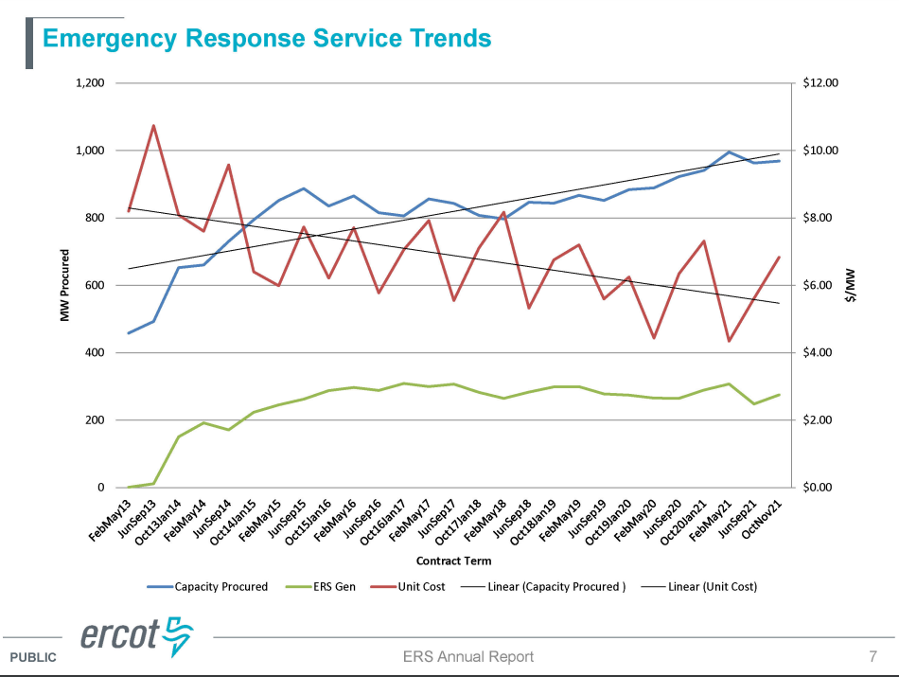
While establishing a principled MW procurement target could result in clearing the same ERS capacity at a lower cost, further changes to deployment criteria, contracting periods, or other market contexts may alter ERS participation interest in the future and should be avoided. The value of ERS is limited and it does not provide price signals integral to investment in the ERCOT market; therefore, ERS should retain its $50M budget cap while ideally using a demand curve to inform decisions about when to forego ERS capacity if the unit cost is too high.

II. Comments Regarding Discussion Draft
- Deleted §25.507(a): The rule should retain a purpose statement, or in the alternative, some provision to clearly define the scope and intent of ERS
TCPA recognizes that in recent rulemakings the Commission has stricken “Purpose” provisions from rules, concluding that “the purpose of [the rule] section is evident from its title.” TCPA notes, however, that the existing “Purpose” statement in §25.507(a) provides additional details not conveyed by the section title “Electric Reliability Council of Texas (ERCOT) Emergency Response Service (ERS)”. The discussion draft deletes the purpose of the service, which is currently to “promote reliability during energy emergencies.” If this is no longer the purpose of the ERS, the rationale for procurement of a specific quantity would seem unclear. The Commission should retain the “Purpose” section of the service in existing subsection (a). Clearly stating the purpose of ERS will serve to justify the cost to consumers. Further, in the event the Commission finds it appropriate to raise or eliminate the annual maximum expenditure permitted on ERS, describing the purpose of the service will serve to appropriately limit the use of ERS.
- §25.507(a): Deployment “to alleviate an emergency condition” is vague and would benefit from further clarification
Existing §25.507 uses the term “energy emergencies” once (in the Purpose section), and then further specifies that ERS is “to be deployed by ERCOT in an Energy Emergency Alert (EEA) event,” which inextricably links the two. The Discussion Draft deletes both, replacing the EEA deployment condition with “alleviate an emergency condition.”
The term “emergency condition” is undefined in the Commission’s rules; it is defined in ERCOT Protocols as “an operating condition in which the safety or reliability of the ERCOT System is compromised or threatened, as determined by ERCOT,” but that definition is also intertwined with the definitions of “Emergency Notice” and “Energy Emergency Alert.” “Emergency condition” is also not codified in the Commission’s rules.
TCPA supports having clear ERS deployment criteria that market participants can anticipate. EEA is a clearly identifiable deployment trigger, but TCPA believes based on the Commission’s good cause exception granted in the Fall of 2021 that the Commission intends for ERS to be deployed prior to the declaration of an EEA. Accordingly, the Commission should specify the criteria for ERS deployment by specifying its use “prior to an emergency condition” or use different (but clearly defined) terminology and ensure the use of ERS, like other out of market capacity reductions, is appropriately accounted for in energy prices.

- §25.507(a)(2): The Commission should not expand the budget for out-of-market programs without a compelling demonstrated need; instead, a MW target should be set that meets an established standard.
As noted in response to Staff’s question for comment above, ERS is an out-of-market capacity payment that does not provide price signals integral to investment in the ERCOT market, and there is nothing to demonstrate that expanding the budget by 50% would yield positive net benefits. Rather than substantially increasing the cost of ERS, the Commission should instead establish a principled MW procurement target, based on a standard, and cleared against a downward-sloping demand curve that retains and reflects the current $50M annual budget cap.

- §25.507(b): The rule should define ERS and “emergency condition,” especially if the purpose statement is deleted
As noted above, there is value in retaining the substantive content of the proposed-to-be-deleted Purpose section of the rule. TCPA recommends that the Commission establish a definition of ERS if it goes forward with deleting that section. The following closely tracks the definition in ERCOT Protocols:
(x) Emergency Response Service. An emergency service procured and deployed by ERCOT under defined conditions to assist in maintaining or restoring ERCOT system frequency.

Similarly, TCPA suggests the Commission prescribe the use of ERS “prior to an emergency condition” in Subsection (b) of this rule consistent with recent operations changes at ERCOT.

- §25.507(c)(7): The rule should prohibit self-deployment of ERS resources
Allowing self-deployment of ERS resources undermines the effectiveness and value of ERS – if an ERS resource would already self-deploy prior to ERCOT’s deployment and the ERS clearing price does not otherwise provide investment signals for the ERCOT market, then the ERS payment did not provide any incremental reliability value. Especially during or in efforts to avoid emergency conditions, it is important that ERCOT receive the reliability value contracted for when called upon.
For example, in ERCOT’s 2021 Annual ERS Report, ERCOT shows that on February 15, 2021 the vast majority of the ERS curtailment had already occurred at the time the ERS Verbal Dispatch Instruction was given:
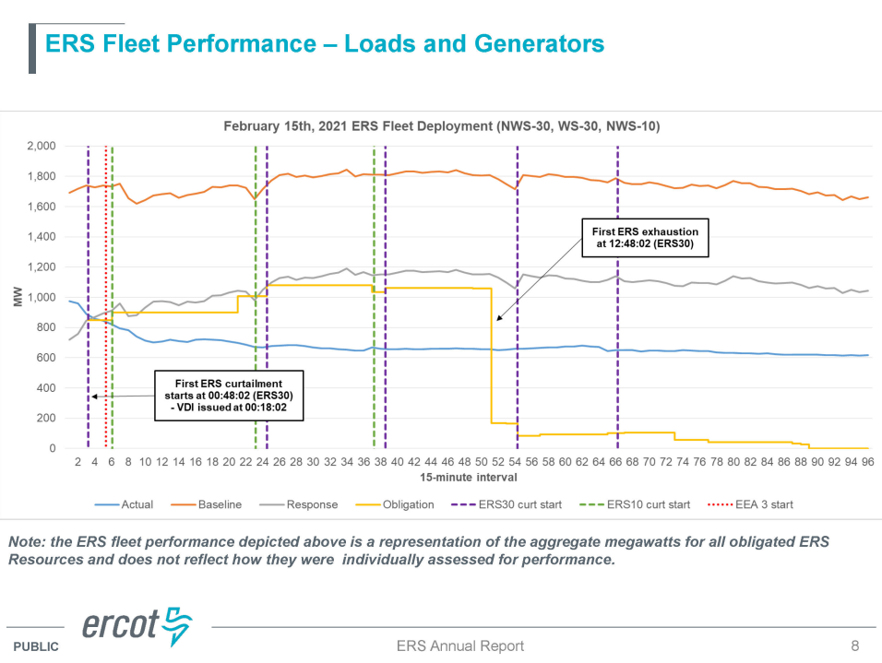
Because the Discussion Draft proposes to move §25.507(c)(7) to its own §25.507(d), the Commission could provide this clarification in the vacated §25.507(c)(7), which would naturally follow from §§25.507(c)(3)-(6) (and in particular, is conceptually aligned with §25.507(c)(4)). Accordingly, TCPA recommends the following new §25.507(c)(7):

(c)(7) ERS resources must achieve their obligations relative to their status at the time of ERCOT’s deployment of ERS.

- §25.507(d): The phrase “as necessary” should be limited to system-wide needs and should not be used for “local” purposes.

ERS is intended to be a system-wide capacity product and should not be used “as necessary” on a locational basis. Use of a local ERS: (1) has significant operational challenges and has therefore been rejected by the Commission in a prior ERS rulemaking; and (2) undermines locational marginal prices. The Commission should preclude dispatch of ERS for non-emergency localized transmission issues as this stifles appropriate price formation consistent with the energy-only nodal market. If the Commission finds it necessary to send better local price signals, it can better achieve this goal through non-discriminatory market reforms that are available to all resource types. Additionally, ERS deployments are out of market capacity procurements and must be accounted for to ensure minimal disruption to the wholesale market. Therefore, the following change to the proposed draft rule subsection (d)(1) are recommended:

(d) Deployment. ERCOT may deploy ERS resources as necessary, subject to the annual expenditure cap, except that ERCOT may not deploy ERS resources to address local transmission constraints. ERCOT may create two ERS products. In one product, deployment of an ERS resource will be limited to a maximum of eight cumulative hours in an ERS contract period. In the second product, deployment of an ERS resource will be limited to a maximum of 24 cumulative hours. However, if an instruction causes the cumulative total ERS deployment time to exceed the maximum time within a contract period, each ERS resource must remain deployed until permitted by ERCOT procedures or by ERCOT instructions to return from deployment. ERCOT must account for the impact of ERS deployment in wholesale energy prices.

- Utility load management programs compete with ERS. A cost effectiveness comparison should exist.
As an emergency reliability product, ERS serves the same purpose as the existing utility load management programs. A key difference between the two is the method of cost recovery for each. Utility load management program costs are evaluated for prudence and then approved by the Commission in energy efficiency cost recovery factor (“EECRF”) proceedings. The Commission should have an opportunity to analyze the effectiveness in improving or preserving reliability during emergency events as between ERS and the load management programs to evaluate the need for further reforms. Accordingly, the Commission should receive reports on these load management programs similar to those contemplated in subsection (g). Therefore, the following addition to the draft language in subsection (g) is recommended:
(g) Reporting.
(1) Prior to the start of an ERS contract period, ERCOT must report publicly the number of megawatts (MW) procured per ERS time period, the number and type of ERS resources providing the service, and the projected total cost of the service for that ERS contract period. ERCOT must review the effectiveness and benefits of ERS and report its findings to the commission annually by April 15 of each calendar year. The report must contain, at a minimum, the number of MW procured in each period, the total dollar amount spent, the number and level of EEA events, and the number and duration of deployments.
(2) By April 15 of each year, ERCOT must report, per electric utility, the number of MW and corresponding total dollar amounts saved by load management programs during EEA events each calendar year for utilities with such programs approved by the Commission in Energy Efficiency Cost Recovery Factor proceedings. Utilities shall provide any information necessary to ERCOT to assist in this analysis.

III. Conclusion
TCPA appreciates the Commission’s consideration of these comments and looks forward to working with other interested parties in this rulemaking.

Dated: May 18, 2022

Respectfully submitted,

Michele Richmond

Executive Director

Texas Competitive Power Advocates (TCPA)

(512) 653-7447
michele@competitivepower.org

PROJECT NO. 53493
EMERGENCY RESPONSE SERVICE | §  §  § | BEFORE THE  PUBLIC UTILITY COMMISSION  OF TEXAS

EXECUTIVE SUMMARY OF TCPA COMMENTS

Comments in Response to Staff Question
- ERS is a system-wide capacity product that only load and generation resources that do not participate in security-constrained economic dispatch (“SCED”) may provide. A specific megawatt (“MW”) quantity implies a specific capacity need. If the Commission desires for ERCOT to procure ERS based on a specific MW quantity, such quantity should be tied to a specific reliability standard set by the Commission.

Comments Regarding Discussion Draft
- Deleted §25.507(a): The rule should retain a purpose statement, or in the alternative, some provision to clearly define the scope and intent of ERS.
  - As an emergency reliability service, ERS serves an important purpose that should be clearly stated in the rule to justify the cost to consumers and to frame the parameters of its use appropriately. Such use should fall within ERCOT’s discretion as needed, but ERCOT should not utilize ERS to address locational transmission issues.
- §25.507(a): Deployment "to alleviate an emergency condition" is vague and would benefit from further clarification to be consistent with recent Commission direction to deploy ERS “prior to an emergency condition,” and the rule should specify that ERS deployments are appropriately accounted for in energy prices.
- §25.507(a)(2): The Commission should not expand the budget for out-of-market programs without a compelling demonstrated need; instead, a MW target should be set that meets an established standard.
  - If the Commission chooses to set a megawatt-specific procurement amount for ERS, this should be tied to a reliability standard set by the Commission.
- §25.507(b): The rule should define ERS and “emergency condition,” especially if the purpose statement is deleted.
- §25.507(c)(7): The rule should prohibit self-deployment of ERS resources
- §25.507(d): The phrase “as necessary” should be limited to system-wide needs and state that that ERCOT may not deploy ERS to resolve local transmission congestion or constraints.
- §25.507(g): The Commission should have a mechanism for evaluating and comparing the effectiveness of ERS with that of utility load management programs that serve similar functions, and therefore should receive performance reports as contemplated by the discussion draft for both ERS and load management programs.

TCPA is a trade association representing power generation companies and wholesale power marketers with investments in Texas and the Electric Reliability Council of Texas (ERCOT) wholesale electric market. TCPA members and their affiliates provide a wide range of important market functions and services in ERCOT, including development, operation, and management of power generation assets, power scheduling and marketing, energy management services and sales of competitive electric service to consumers. TCPA members participating in this filing provide nearly ninety percent (90%) of the non-wind electric generating capacity in ERCOT, representing billions of dollars of investment in the state, and employing thousands of Texans. TCPA member companies participating in these comments include: Calpine, Cogentrix, Constellation (formerly Exelon), EDF Trading North America, Luminant, NRG,, Talen Energy, Tenaska, TexGen Power, and WattBridge.
Staff Discussion Draft Proposed Changes to § 25.507, Project No. 53493 (Apr. 28, 2022).
See Electric Reliability Council of Texas, Inc.’s 2021 Annual Report on Emergency Response Service at 7, filed on April 15, 2022 in Project No. 52933 (“ERCOT 2021 ERS Report”)
See Reorganization of 25.505, Project No. 53191, Order at 3, 9, and 10 (April 29, 2022).
See 16 TAC § 25.507(b)
See Review of Wholesale Electric Market Design, Project No. 52373, Commission Staff’s Motion for Good Cause Exception (October 27, 2021) and Order Granting Good Cause Exception (November 4, 2021).
ERCOT Nodal Protocols, Section 2 at 28 (May 13, 2022).
ERCOT 2021 ERS Report at 8.
See e.g. Rulemaking Regarding Emergency Response Service, Project No. 45927, Order Adopting Amendments to § 25.507 at 8 (Mar. 30, 2017) (“The commission understands the concern expressed by the IMM that the creation of a separate local deployment product for ERS is a complex undertaking, and agrees with ERCOT that the existing ERS program is not well-suited to local deployment to address transmission emergencies”).
See id at 9 (“Several parties pointed to the potential for localized price suppression when ERS is deployed to address local congestion issues, and argued that this effect would not be addressed through existing mechanisms, such as the Reliability Deployment Price Adder. The commission agrees that the effects of out-of-market reliability actions on local price formation is a concern, and the effects on nodal prices of the deployment of ERS to forestall local transmission emergencies would not be addressed through existing pricing mechanisms”).

