FOR IMMEDIATE RELEASE
Contacts: press@poweringtexans.com; media@competitivepower.org
July 15, 2026
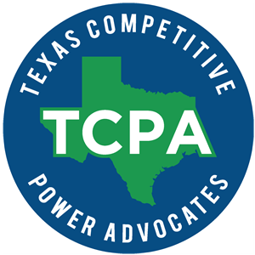

Powering Texans, Texas Competitive Power Advocates Join Forces to Advocate for Policies to Strengthen Texas Grid Reliability

AUSTIN, TEXAS — Today, through a new formal agreement, Powering Texans and Texas Competitive Power Advocates (TCPA) announced the two organizations are joining forces to speak with one voice on behalf of the companies investing in and operating the reliable, dispatchable generation resources that keep the lights on and power the Texas economy. Collectively, the members of Powering Texans and TCPA operate more than 60,000 MW of generation capacity in the Electric Reliability Council of Texas (ERCOT) grid.

“As Texas experiences historic growth and rising electricity demand, a unified voice on forward-thinking policies that will strengthen our state’s grid in the coming decades has never been more important,” Powering Texans CEO Walt Baum and TCPA President & CEO Michele Richmond said in a joint statement announcing the partnership.

“Together, we will advocate for policies that support both existing and new generation resources – particularly thermal generation – which remain essential to meeting growing demand, maintaining grid reliability, and ensuring Texas continues to lead the nation in economic growth and opportunity.”

As part of the collaboration outlined in the agreement, Powering Texans will be representing the industry at the Texas Legislature and TCPA will be representing the industry at the Public Utility Commission of Texas (PUCT), ERCOT and various state and regulatory agencies.

Powering Texans is a trade association representing Texas’ leading power generators, advocating for free market policies and principles within the Texas energy landscape and promoting the general welfare of all Texans. By keeping the energy market free from excessive government control, we seek to promote investment, encourage competition, and deliver a stronger grid for Texans, their businesses, and their families. To learn more, visit https://poweringtexans.com/

Texas Competitive Power Advocates (TCPA) is a trade association representing power generators, and wholesale power marketers with investments in Texas and the ERCOT wholesale electric market. TCPA members are dedicated to helping ensure a successful energy future for Texas by investing in and operating diversified energy sources to ensure ample, reliable and affordable electricity for Texas consumers. To learn more, visit https://competitivepower.org/

###

